
Project report on

Hospital Patient Management Dashboard
(MBA Data Science and AI)



Submitted by:

Group Name: Group 2
Members:

Samiksha Kapoor

Tathagat Jain

Pooja Gupta

Ankita Sharma
Dataset Name: Hospital Management Dataset
Date of Submission: 6th November 2025

Introduction
Brief Background of the Domain
The healthcare sector generates a vast amount of data daily through patient admissions, treatments, and hospital operations.
Managing this data efficiently is crucial for improving hospital performance and patient satisfaction. A Hospital Patient Management
System ensures smooth tracking of patient flow, doctor performance, and departmental productivity. By integrating hospital data
into an analytical tool like Power BI, healthcare administrators can gain real-time insights into operational efficiency, identify
performance bottlenecks, and make data-driven decisions to enhance the quality of care and service delivery.
Description of the Dataset
The dataset used for this project consists of key variables that help analyze hospital performance, patient flow, and satisfaction. Each variable plays a specific role in the overall analysis and dashboard visualization.
- Date:
Represents the specific day on which the hospital data was recorded. It helps in analyzing patient trends and revenue over time.
- Department:
Indicates the hospital department (such as Cardiology, Orthopedics, Surgery, ENT, Dermatology, etc.).
This variable helps in comparing performance across different departments.
- Doctor:
Refers to the name or ID of the doctor treating patients in each department.
It allows evaluation of individual doctor performance and workload.
- Patients Treated:
Shows the total number of patients handled by each doctor or department on a given date.
This metric is used to measure service volume and hospital efficiency.
- Average Treatment Cost:
Represents the average amount charged per patient in a department or by a doctor.
It is used to calculate total revenue and assess cost-effectiveness.
- Satisfaction Rating:
Reflects the average patient satisfaction score (typically on a scale of 1 to 5).
This variable is used to monitor quality of care and identify areas needing improvement.
- Total Revenue (Calculated Column):
A derived metric calculated using the formula:
Total Revenue = [Patients Treated] * [Average Treatment Cost]
It indicates the total income generated by each doctor or department.
- Revenue per Patient (DAX Measure):
Another calculated metric derived using the formula:
Revenue per Patient = DIVIDE(SUM([Total Revenue]), SUM([Patients Treated]))
It helps evaluate the average revenue generated per patient, allowing comparison of financial performance between departments.
Number of Fields (Columns): 6
Key Columns: Department, Doctor, Patients Treated, Avg Treatment Cost, Satisfaction Rating
Data Type: Tabular (.xlsx / .csv format)
Objective
The main objective of this project is to design an interactive Power BI dashboard that allows hospital administrators to:
- Monitor patient flow across departments
- Evaluate doctor performance and productivity
- Assess patient satisfaction levels
- Measure revenue generation and cost efficiency
- Identify departments with improvement opportunities
Data Preparation
Before visualization, the dataset was cleaned and transformed to ensure consistency and accuracy.
Data Cleaning & Transformation Steps
1.Initially cleaned the dataset in Microsoft Excel by removing unnecessary rows, correcting data formats, and ensuring consistency.
2. Converted the Date Field into a valid Date data type.
3. Checked for Missing or Inconsistent Values in numerical columns such as Patients Treated and Avg Treatment Cost.
4. Created Calculated Columns using DAX formulas for financial metrics.
5. Applied Conditional Formatting to highlight low satisfaction departments.
Calculated Columns & DAX Measures
Total Revenue = [Patients Treated] * [Avg Treatment Cost]
Revenue per Patient = DIVIDE(SUM([Total Revenue]), SUM([Patients Treated]))
KPIs Created:
- Total Patients
- Total Revenue
- Average Satisfaction Rating
Visualization & Analysis
Several Power BI visuals were created to analyze and interpret hospital performance.
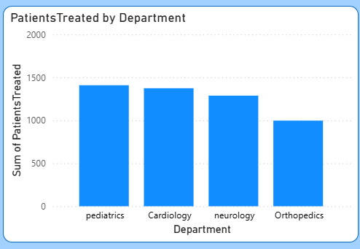
Bar Chart – Patients by Department:
Displays the number of patients treated in each department, highlighting high-demand areas such as Cardiology and General Medicine.
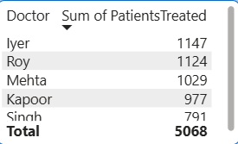
Table – Doctor vs. Patients Treated:
Compares doctors based on the number of patients handled, helping identify top performers and workload distribution.
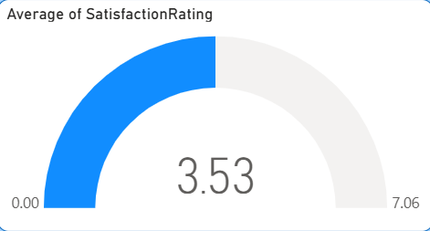
Gauge Chart – Average Satisfaction Rating:
Shows the overall patient satisfaction level, offering a quick snapshot of service quality across the hospital.
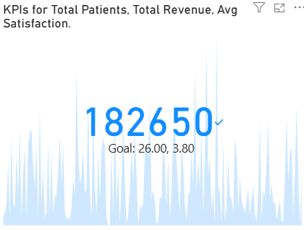
KPI Cards – Total Patients, Total Revenue, and Average Satisfaction:
Summarize key performance metrics, providing a concise overview of hospital efficiency and outcomes.
Insights & Findings
From the dashboard analysis, the following insights were identified:
1. High Patient Volume Departments: Departments like Cardiology and Orthopaedics consistently handle the highest patient loads.
2. Revenue Distribution: Surgery and Cardiology departments contribute significantly to total revenue.
3. Satisfaction Levels: Departments such as ENT and Dermatology show lower satisfaction scores.
4. Doctor Performance Variation: Some doctors manage higher patient loads with good satisfaction ratings.
5. Efficiency Improvement Opportunities: Departments with low patient volume but high costs could optimize resource use.
Conclusion
The Hospital Patient Management Dashboard provided valuable insights into patient flow, department performance, and doctor efficiency.
Power BI enabled the integration of multiple performance indicators into a single, interactive view that simplifies decision-making for hospital administrators.
Recommendations
1. Enhance Low Satisfaction Departments: Conduct patient feedback reviews to identify service issues.
2. Resource Reallocation: Reassign staff or resources to balance workloads.
3. Performance Incentives: Recognize top-performing doctors to maintain motivation.
4. Continuous Monitoring: Update the dashboard regularly for ongoing improvement.
